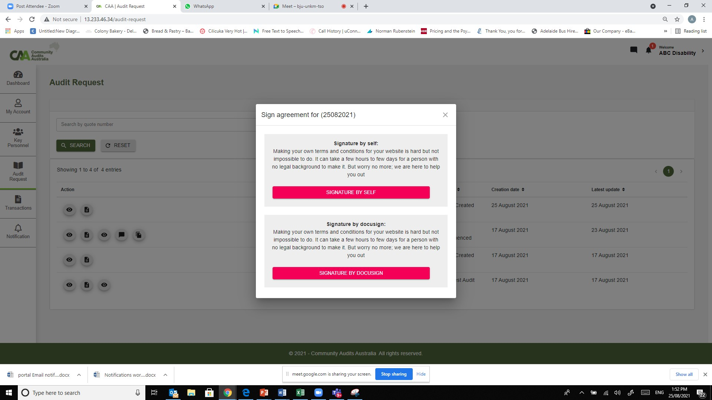

Sign online digitally

Download and sign in hard copy

Sign agreement for Ref (Quote) #

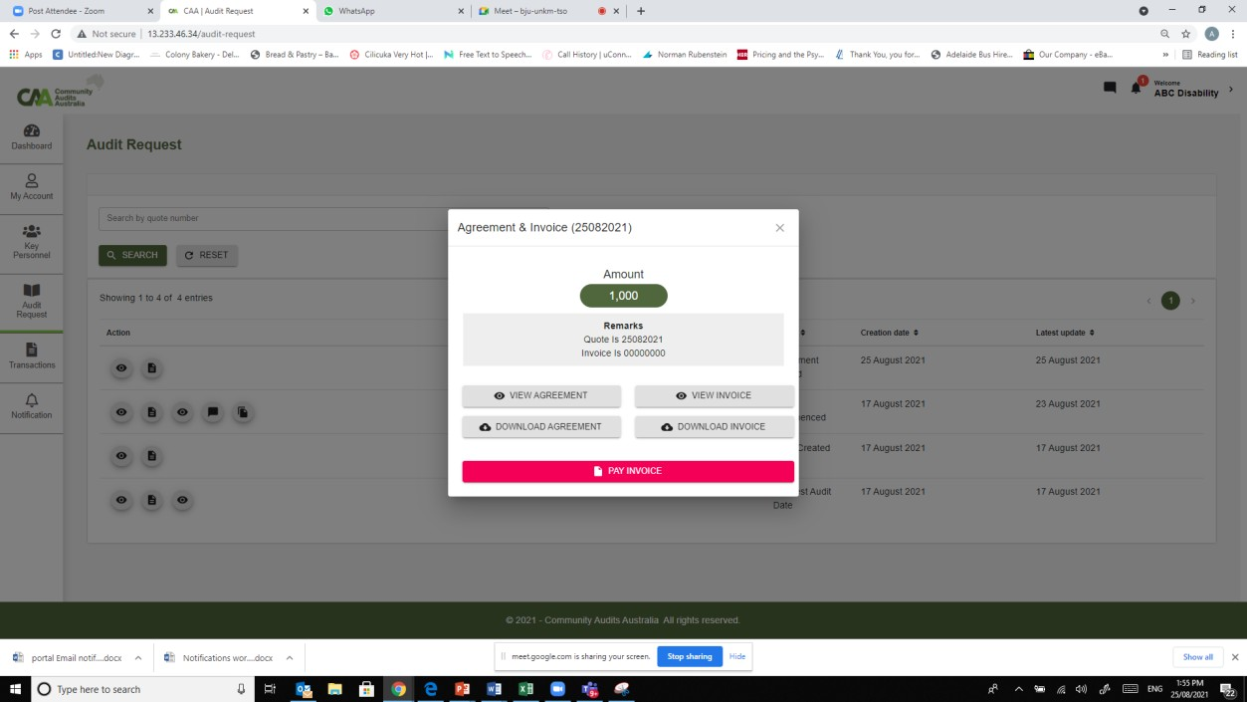

After agreement signed, need a $ button here to click to make payment. As discussed with Seb, the latest & outstsanding action is in red

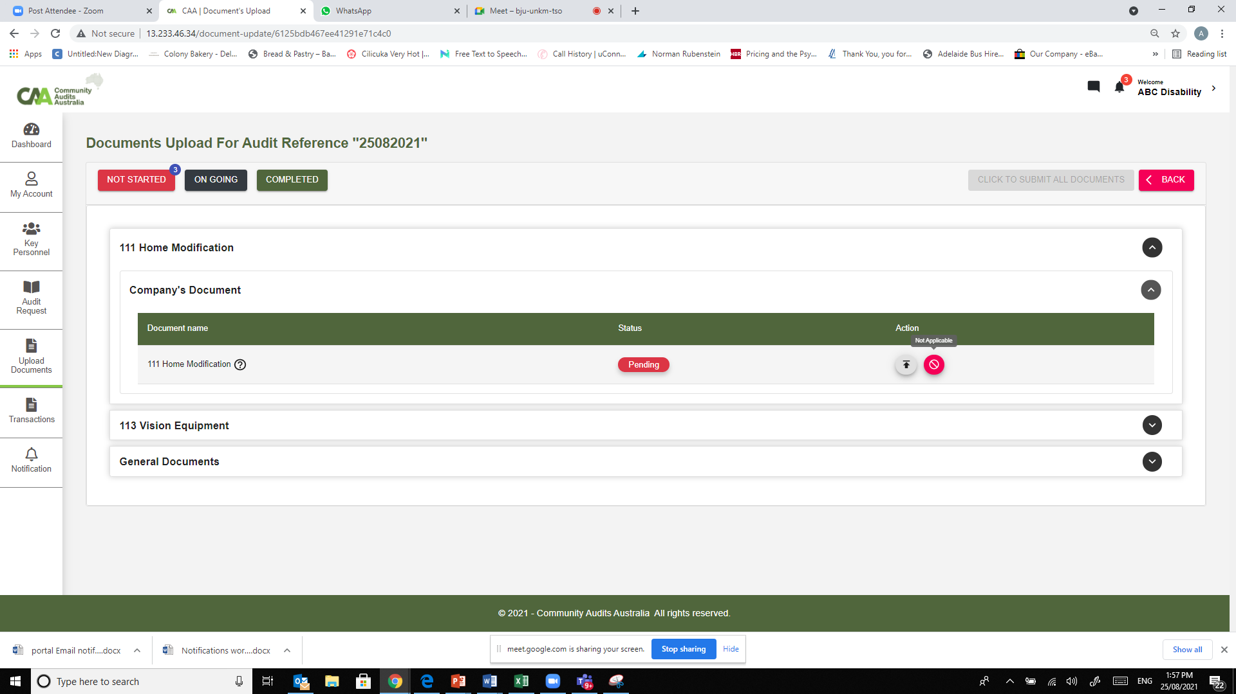

Colour od upload = green, Not applicable is grey & Wording change to “Document not needed”

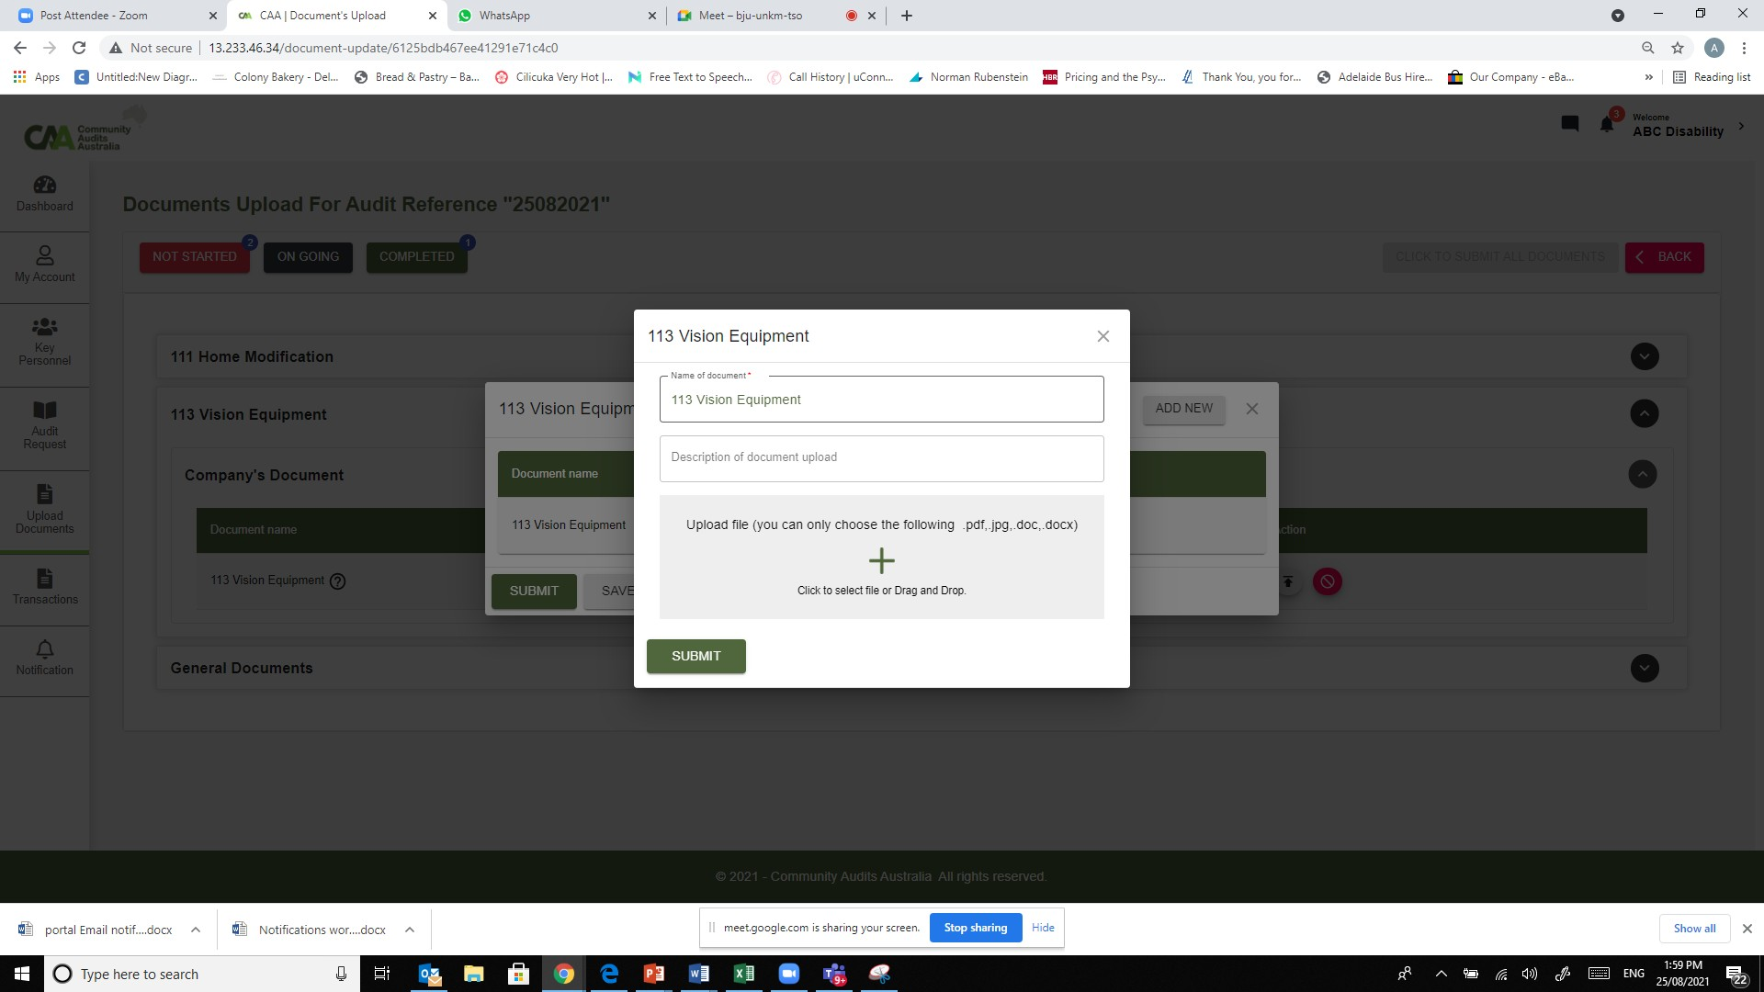

Submit for this is good

“Save” for multi doc upload.

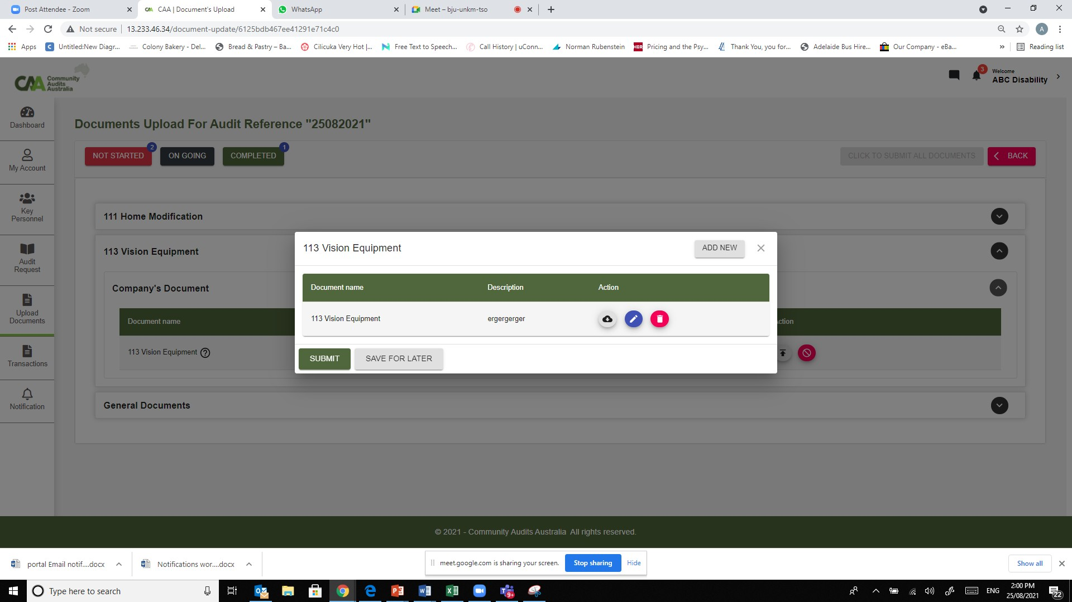

Green for add new

All buttons grey

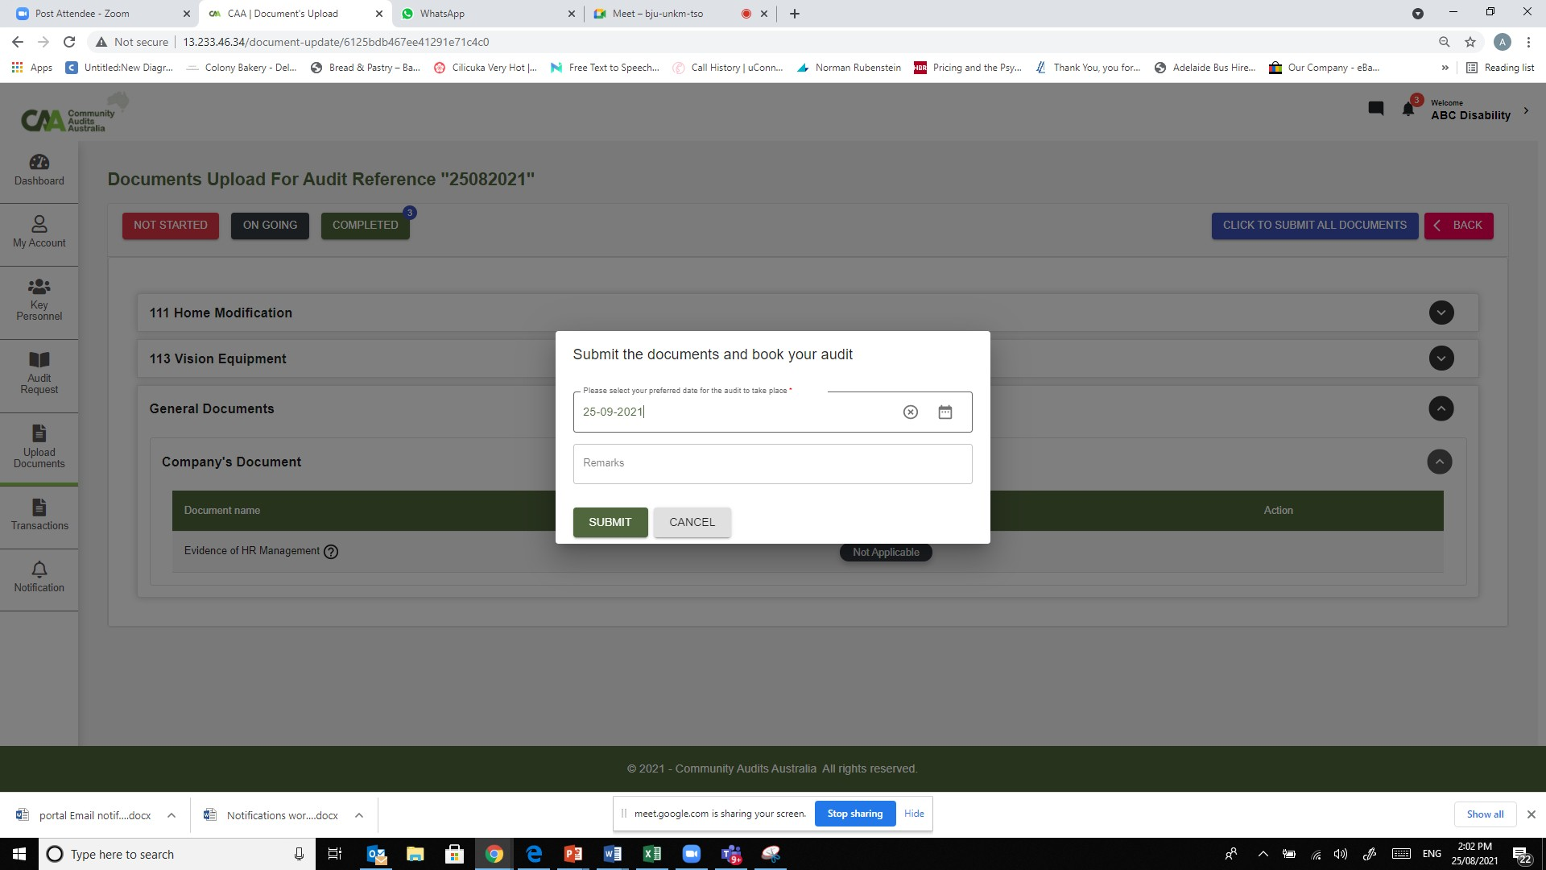

Green button. Wordings “Click to submit & Request audit date”

“Request your booking date & Submit documents”

“Submit & Request audit date”

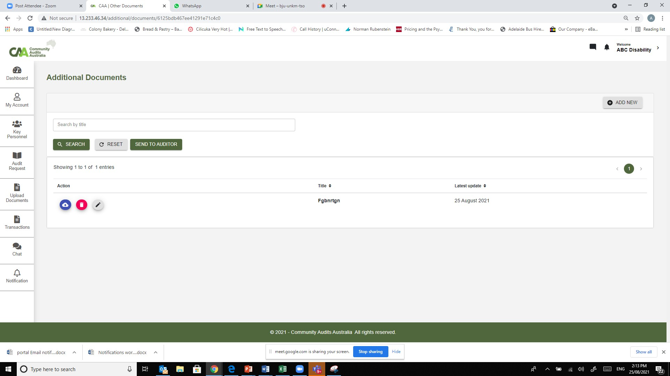

All grey colour

Move send to auditor button to above next to “Add new”

Remove search function

Green button.